Operadores lógicos Python
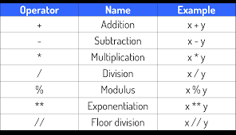
- Si a = 5, b = 2, resolver:
A % b
5 % 2
1

- Si a = 7, b = 4, resolver:
A % b
7 % 4
3

- Si a = 11, b = 2, resolver:
A % b
11 % 2
1

- Si a = 21, b = 6, resolver:
A % b
21 % 6
3

Operador Exponenciación

- Si x = 4, Y = 2, resolver:
X ** Y
4 ** 2
16

- Si x = 4, Y = 2, resolver:
X ** Y
2 ** 4
16

- Si x = 1, y = 50, resolver:
- X ** Y
1 ** 50
1

- Y ** X
50 ** 1
50

Operador división entera
- Si x = 11, Y = 5, resolver
X // Y
11 // 5
2

- Si x = 21, y = 4, resolver
X // Y
21 // 4
5

- Si x = 80, y = 9, resolver
X // Y
80 // 9
8

Operadores Racionales
- Si a =1, b=2, c=3 resolver:
  - A + B == C
1 + 2 == 3
3 == 3
True

  - (b*c)%a !=0
B * C
2 * 3
6
6 % a
6 % 1 != 0n
0 != 0
False

  - A ** 50 + b + 3 >= 6
A ** 50
1 ** 50
1
1 + 2
3 + 3
6 >= 6
True

  - C * 3 >= b * 2 + 5 ** a
C * 3 >= 2 * 2 + 5 ** 1
3 * 3 >= 2 * 2 + 5
9 >= 4 * 5
9 >= 9
True

- si a=2, b=4 , c=8 resolver

- (c%a*b)+c*1 == (b//a)+c or

